# Final Year Project Game Proposal

## Genre and Setting

The game is an adaption of the infinite runner genre.

It is set in a simple, stickman style, 2D world.

The game consists of a moving mining cart and multiple obstacles which the player must avoid.

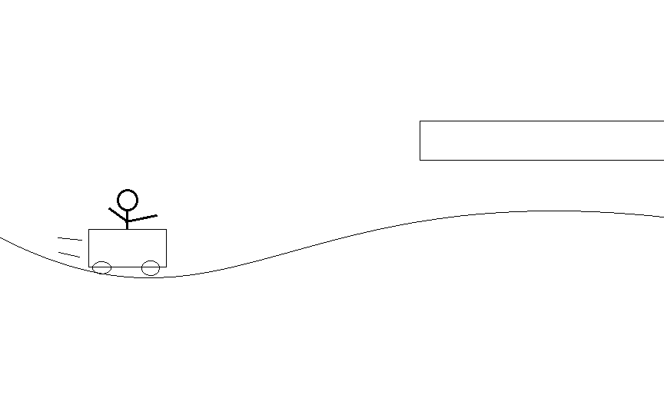

## Player Details

The player controls a stickman who travels in the mining cart.

There are two versions of the game up in the air at the minute:

1. Their objective is to get as far as possible without dying, thus setting a high score. The terrain would have to be randomly generated in this scenario.
2. There would be levels which the player would set high-scores on and would be given a rating at the end of each level. There would then be bonus objects in hard to reach places which would be required to achieve the best ranking.

The player controls the game character using the Kinect. He/she must duck, jump and run to avoid obstacles and transition between mining carts.

## Project Details

The game will implement a physics engine. It may incorporate online high-score tables and AI units which try to block the player.

I would like to develop the game in XNA (or MonoGame) using the Kinect for Windows SDK and Box2D.XNA.

Alternatively I could use SFML but I think this would lengthen the development process and the game would end up less polished.

I would like to learn how to use the Kinect sensor as an input device and use the technology in a novel way.